EXPERIMENT-1
- Perform basic Image Handling and processing operations on the image is to read an image in python and Convert an Image to Gray-scale.

- CODE
- from PIL import Image

- img = Image.open("photo.jpg")

- gray = img.convert("L")

- gray.save("gray_photo.jpg")

- print("Image converted to grayscale successfully")

b) INPUT
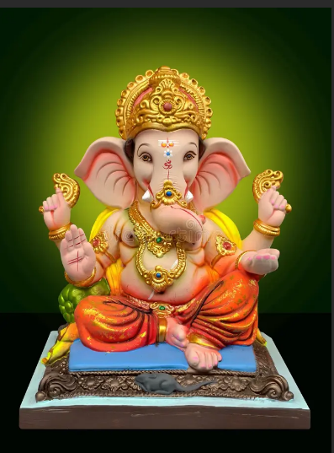
c) OUTPUT
